Workshop for New Darwin Plus Projects
Comms Strategy and M&E Plan

Developing your communications strategy
During the workshop session, we asked you to work in small groups to consider the communications strategy for your project. It can be helpful to work through this exercise with your project teams after the workshop too, so we wanted to make sure you had the templates available.
Think about:
- In general, briefly consider why you think you need to communicate - What issues? Influence? Engagement? Expectations? You might find these thoughts are different at the end of the exercise.

- Audiences: WHO should you be communicating with. Stakeholder analysis is useful:
  - Who are the key groups of people you need to communicate with?
  - Do you want two-way interaction or to give out messages or information?
  - Consider their interest in/influence on your project
  - Prioritise “easy wins” to focus on for best results
Step 1: Develop an influence vs interest map of stakeholders from your project. The key box to focus on is the bottom right – high influence and low interest. How can you increase their engagement?
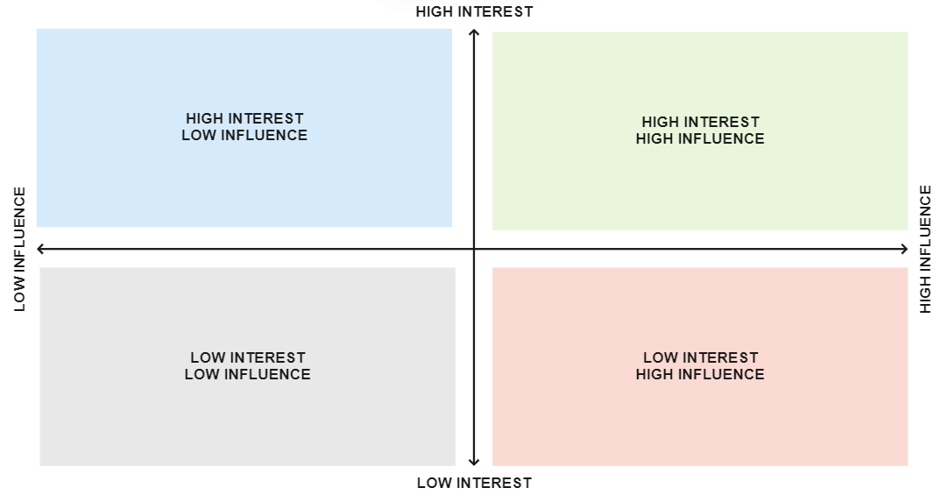

Step 2: Taking the audiences above, develop a simple communications strategy for your project
Here is an example:
Target audience | Why communicate? | Intended outcome | Priority | Communication products/methods | Cost/ level of effort/ responsibility
Darwin /IWT applicants | Clarity on Darwin/IWT aims & goals, leading to better applications and better projects. | Stronger applications leads to strong projects = greater impact | High | - Application guidance notes  - Newsletter  - Stage 2 workshop  - Twitter  - Blog posts
UK public | Access to information on value and benefits of DI and responsible use of tax-payer’s money, leading to understanding of and support for the investment. | Continued investment in Darwin/IWT programme | Medium | - Guidance to projects on mentioning Darwin  - Twitter  - Press office support for press releases

Developing an M&E plan
Below is a fairly basic but still comprehensive pro-forma M&E action plan. Working with your project team, and using indicators from your logframe, prepare an M&E plan for your project (N.B. this isn’t something Darwin Plus requires you to have but we strongly recommend it!). This can be a useful exercise to carry out with your project team at the start of your project to ensure everyone is familiar with the logframe and how you will be using it during your project.

At the same time, you may want to consider whether indicators could be made more ‘SMART’. Any changes to your logframe at the level of Impact, Outcome or Output should be agreed via the Change Request Process. Activity level changes do not need to be agreed unless there is associated rebudgeting or changes to higher-level elements of your project/logframe.

Expected Results  Chain | Indicators | Rationale (how does this link to the Outcome/ Output?) | Baseline (if not yet established, outline when/how it will be) | Targets | Data sources.  This could include primary or secondary data. | Methodology | Freq. | Templates (how will data be recorded?) | Budget allocation | Responsibility (who will monitor progress towards this indicator/collect necessary data?) | Additional Comments
e.g. Outcome | e.g. Outcome indicator 0.1
e.g. Output 2 | e.g. Output Indicator 2.3

